A PROJECT REPORT ON

## DEPRESSION DETECTION USING FACIAL EXPRESSION & TEXT MINING

SUBMITTED TO THE SAVITRIBAI PHULE PUNE UNIVERSITY, PUNE

IN PARTIAL FULFILLMENT OF THE REQUIREMENTS

FOR THE AWARD OF THE DEGREE

**BACHELOR OF ENGINEERING**

*In*

**COMPUTER ENGINEERING**

*Of*

**SAVITRIBAI PHULE PUNE UNIVERSITY**

*By*

**RUSHIKESH LAHOLE ROLL NO: Exam Seat No:**

**KETAN KULKARNI ROLL NO: Exam Seat No:**

**JAYDIP BHADANE ROLL NO: Exam Seat No:**

**ROHAN KAMBLE ROLL NO: Exam Seat No:**

Under the guidance

Of

**PROF. MADHAVI KULKARNI**



**DEPARTMENT OF COMPUTER ENGINEERING**

**JSPM’s BHIVARABAI SAWANT INSTITUTE OF TECHNOLOGY & RESEARCH, WAGHOLI, PUNE - 412207**

**2021-2022**

Date:

# CERTIFICATE

This is to certify that the project report entitled

## “ DEPRESSION DETECTION USING FACIAL EXPRESSION & TEXT MINING ”

Submitted by

**RUSHIKESH LAHOLE Exam Seat No.:**

**KETAN KULKARNI Exam Seat No.:**

**JAYDIP BHADANE Exam Seat No.:**

**ROHAN KAMBLE Exam Seat No.:**

is a bonafide student of this institute and the work carried out by him/her under the supervision of **Prof. Madhavi Kulkarni** and it is approved for the partial fulfillment of the requirements of Savitribai Phule Pune University, Pune for the award of the degree of Bachelor of Engineering (Computer Engineering) during the year 2021-22.

Prof. Madhavi Kulkarni Prof. Gayatri Bhandari

Guide Head

Department of Computer Engineering Department of Computer Engineering

Prof. T. K. Nagraj

Principal

JSPM’s BHIVARABAI SAWANT INSTITUTE OF TECHNOLOGY & RESEARCH, WAGHOLI, PUNE - 412207

# Acknowledgement

It gives us a great pleasure in presenting the paper on “**Depression Detection Using Facial Expression & Text Mining”**. We would like to take this opportunity to thank **Prof. G. M. Bhandari** Head of Computer Engineering Department JSPM’s BHIVARABAI SAWANT INSTITUTE OF TECHNOLOGY & RESEARCH, WAGHOLI, PUNE for giving us all the help and support we need during course of the Paper writing work. We are really grateful to him. Our special thanks to Principal **Dr. T. K. Nagraj** who motivated us and created a healthy environment for us to learn in the best possible way. We also thank all the staff members of our college for their support and guidance.

**Rushikesh Lahole**

**Ketan Kulkarni**

**Jaydip Bhadane**

**Rohan Kamble**

# Abstract

Depression might be considered as one of the most serious social health problems in the modern society. Mentally ill or Depressed people thought of committing suicide. It can be regarded as a risk indicator of suicide. India is among the top countries among in the world to have annual suicide rate. Objective of Face Emotion Recognition (FER) is identifying emotions of a human for reduce the suicide rate. This system involves extraction of facial features, and threshold detection of stress using emotions expressed through face using the (CNN, 2.17)algorithm. This system is basically used to classify positive and negative emotions and detects the stress based on usual threshold value.

**Keywords:** Suicide rate, Emotions, Convolutional Neural Network.

# List of Figures

**Figure Name Page No.**

1.1 Suicide Death In India As A Percentage Of World 1

1.4 CNN 5

2.3 Waterfall Model 10

3.1.1.1 Face Detection 14

3.1.1.2 Emotion Detection 15

3.1.1.3 Feature Extraction 15

3.1.1.4 Emotion Recognition 16

3.2.1 Methodology Of The System 18

3.4 NP Problem 19

3.5 Architectural Diagram 20

3.6.1 Data Flow Diagram 23

3.6.2 Use case Diagram 24

3.6.3 Sequence Diagram 25

3.6.4 Class Diagram 26

3.6.5 Activity Diagram 27

3.6.6 Component Diagram 28

5.1 Face Detection 29

# List of Tables

**Table name Page No.**

2.4.2 Estimated Loc 11

2.5. Timeline Chart 13

# Abbreviations

CNN Convolutional Neural Network

CSS Cascade Style Sheet

DCNN Deep Neural Network

DFD Data Flow Diagram

HTML Hypertext Markup Language

KNN K-Nearest Neighbors

LOC Line of Code

SNS Social Network Sites

SVM Support Vector Machine

# Index

**Chapter No. Title Page No.**

1. **INTRODUCTION** 1
   1. Background and Basics 1

1.1.1 Overview 2

1.1.2 Motivation 2

* 1. Literature Survey 3
  2. Project Undertaken 4
     1. Problem definition and objectives 4
     2. Project Scope 4
  3. Methodologies of problem solving 4

1. **PROJECT PLANNING AND MANAGEMENT** 6

2.1 Introduction 6

2.2 System requirement specification 6

2.2.1Detail System Requirement specification 6

2.2.2 System Overview 6

2.2.2.1Assumptions and dependencies 6

2.2.2.2 Functional Requirement 6

2.2.2.3 Nonfunctional requirement 7

2.2.2.4 System Requirement 8

2.3 Project Process Model 9

2.4 Cost &Efforts Estimate 11

2.5 Project Scheduling 13

1. **ANALYSIS & DESIGN** 14

3.1 Introduction 14

3.1.1 Methods and Material 14

3.2 Idea Matrix 16

3.2.1 Methodology 17

3.3 Mathematical Model 18

3.4 Feasibility Analysis 18

3.5 Architecture Diagram 20

3.5.1 Tools and technology used 20

3.5.2 Algorithm Details 21

3.6 UML Diagram 22

3.6.1 Data flow diagrams 23

3.6.2 Use Case Diagram 24

3.6.3 Sequence Diagram 25

3.6.4 Class Diagram 26

3.6.5 Activity Diagram 27

3.6.6 Component Diagram 28

4. **RESULT & DISCUSSION**

4.1 GUI SNAPSHOT 27

4.2 DISCUSSION 28

5. **CONCLUSION** 29

**REFERENCES** 30

# CHAPTER 1

## INTRODUCTION

**1.1 Background and basics**

Suicide is an important issue in the Indian context. More than one lakh (one hundred thousand) lives are lost every year to suicide in our country. In the last two decades, the suicide rate has increased from 7.9 to 10.3 per 100,000. There is a wide variation in the suicide rates within the country. The southern states of Kerala, Karnataka, Andhra Pradesh and Tamil Nadu have a suicide rate of > 15 while in the Northern States of Punjab, Uttar Pradesh, Bihar and Jammu and Kashmir, the suicide rate is < 3. This variable pattern has been stable for the last twenty years. Higher literacy, a better reporting system, lower external aggression, higher socioeconomic status and higher expectations are the possible explanations for the higher suicide rates in the southern states.

In 2020 the number of suicides in India had increased to 250,354. Suicide was the most common cause of death in both the age groups of 15-29 years and 15-39 years. About 900,000 people die by suicide worldwide every year, of these 135,000 (17%) are residents of India, a nation with 17.5% of world population.

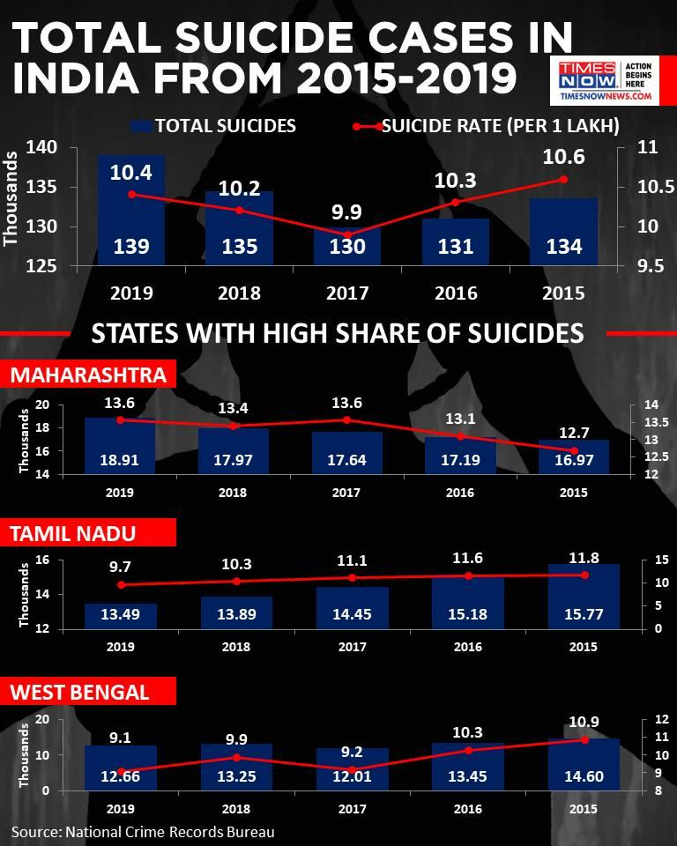

**Fig.1.1 Suicide deaths in India as a percentage of world**

India had the highest suicide rate in the South-East Asian region in 2020, a new report by the World Health Organization (WHO) has revealed. India’s own official statistics, which map the number and causes of suicides in the country, have not been made public for the last three years, hindering suicide prevention strategies and efforts to implement the WHO's recommendations in this regard.

The report presented suicide rates for countries and regions using data from the WHO Global Health Estimates for 2020. When classified according to region and income, India is part of the South-East Asia region and the Lower Middle-Income group of countries. India’s suicide rate (17.5) was higher than the rate of its geographic region (14.4) and the rate of its income group (12.4).

**1.1.1 Overview**

India’s suicide rate stood at 16.5 suicides per 100,000 people in 2016, according to the WHO report. This was higher than the global suicide rate of 10.5.

The objective of this project is to design a system which involves extraction of facial features, and detection of stress using emotions expressed through face using the Convolutional Neural Network (CNN) algorithm.

This system is basically used to classify positive and negative emotions and detects the stress based on usual threshold value. This system detects the emotions and helps to prevent rate of suicide.

**1.1.2 Motivation**

India reported an average 381 deaths by suicide daily in 2019, totaling 1,39,123 fatalities over the year, according to the latest National Crime Records Bureau (NCRB) data. A 3.4 per cent increase was observed in suicides during 2019 (1,39,123 suicides) as compared to 2018 (1,34,516) and 2017 (1,29,887), the data showed. The rate of suicide (incidents per 1 lakh population) rose by 0.2 per cent in 2019 over 2018, as per the data.

According to the statistics by the NCRB, which functions under the Union Home Ministry, the suicide rate in cities (13.9 per cent) was higher as compared to all-India suicide rate (10.4 per cent) in 2019. The motivation behind designing this project is to reduce the increasing suicidal rate using technique of emotion detection.

**1.2 Literature Survey**

Depression Detection using Emotion Artificial Intelligence proposed by Mandar Deshpande and Vignesh Rao. This paper aims to apply natural language processing on Twitter feeds for conducting emotion analysis focusing on depression. Individual tweets are classified as neutral or negative, based on a curated word-list to detect depression tendencies. In the process of prediction Naive-Bayes classifier have been used.

Facial emotion recognition in real-time and static images proposed by Shivam Gupta This paper aims to detect facial expressions are a form of nonverbal communication. Various studies have been done for the classification of these facial expressions. There is strong evidence for the universal facial expressions of eight emotions which include: neutral happy, sadness, anger, contempt, disgust, fear, and surprise. So it is very important to detect these emotions on the face as it has wide applications in the field of Computer Vision and Artificial Intelligence.

Short Research Advanced Project: Development of Strategies for Automatic Facial Feature Extraction and Emotion Recognition proposed by David Restrepo and Alejandro Gomez. This paper aims to develop a computational way for emotion recognition though images using the Cohn-Kanade database to train a pattern recognition neural network and Viola Jones object detector to extract the information of the facial expression. The resulting neural network showed an overall accuracy of 90.7% in recognizing between 6 basic emotions such a surprise, fear, happiness, sadness, disgust and anger.

Emotion recognition and drowsiness detection using Python proposed by Anmol Uppal, Shweta Tyagi, Rishi Kumar and Seema Sharma. This present the software which detects and recognizes faces as well as tells a lot more about that person which could be used to get feedback from customers or to know if a person needs motivation. Detection of eye blinking is important in certain scenarios where to avoid any accident or mishappening like in vehicles or in security vigilance.

Depression Detection by Analyzing Social Media Posts of User proposed by Nafiz Al Asad, Md. Appel Mahmud Pranto, Sadia Afreen and Md. Maynul Islam. The standard method of detecting depression of a person is a fully structured or a semi-structured interview method (SDI) . In this research, machine learning is used to process the scrapped data collected from SNS users. Natural Language Processing (NLP), classified using Naïve Bayes algorithm to detect depression potentially in a more convenient and efficient way.

**1.3 Project Undertaken**

**1.3.1 Problem definition and objectives**

In early days suicidal rate is increased due to the depression therefore we need a automation system to find depressed person. Therefore, we design system which involves extraction of facial features, and detection of stress using emotions expressed through face using the Convolutional Neural Network (CNN) algorithm and classify positive and negative emotions and detects the stress based on usual threshold value.

**1.3.2 Project Scope**

Social networks have been developed as a great point for its users to communicate with their interested friends and share their opinions, photos, and videos reflecting their moods, feelings and sentiments. This creates an opportunity to analyze social network data for user’s feelings and sentiments to investigate their moods and attitudes when they are communicating via these online tools. This system will use in social media for automatic find person who are depressed using their post. This system can be helpful for psychologists/psychiatrist to cure the patients in near future.

**1.4 Methodologies and Problem Solving**

In this project, Face is captured using the camera. This detected face is processed and the emotions are classified as either positive or negative emotions. The detected image is processed to identify the face of the subject using Convolutional Neural Network (CNN) algorithm.

**Convolutional Neural Network (CNN):**

A Convolutional neural network (CNN) is a neural network that has one or more convolutional layers and are used mainly for image processing, classification, segmentation and also for other auto correlated data. A convolution is essentially sliding a filter over the input.

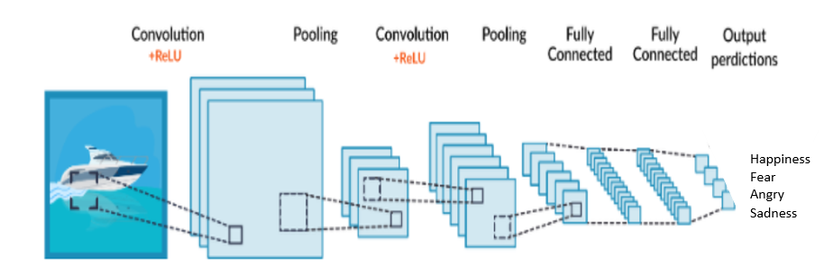

**Fig. 1.4CNN**

A Convolutional Neural Network (ConvNet/CNN) is a Deep Learning algorithm which can take in an input image, assign importance (learnable weights and biases) to various aspects/objects in the image and be able to differentiate one from the other.

# CHAPTER 02

## PROJECT PLANNING AND MANAGEMENT

**2.1 Introduction**

Create ideas and find issues, plan sprints, and distribute tasks across our team. Prioritize and discuss our team’s work in full context with complete visibility. Improve team performance based on real-time, visual data that our team can put to use.

This system require the man per month is divide into following sub activities:

1-Technical training of the team member: This will take nearly 1 months. This will include PYTHON, HTML, CSS etc.

2-Research: Being an innovative project research for the project is an important part currently it seems to have 1 to 1.5 months.

**2.2 System Requirement Specifications (SRS)**

**2.2.1 Detail System Requirement Specifications**

We make a web-based application. It’s used to provide information of depressed person and it is mainly used for display result. Using the SRS helps to ensure whether our project requirements are fulfilled i.e. output generated in text or audio is clear. And it also help us to make decisions about our project lifecycle. Writing an SRS can also minimize overall development time and costs.

* + 1. **System Overview**

**2.2.2.1 Assumption and Dependencies**

We have assumed the system will recognize emotions of person in photograph. The features are extracted from the image and emotion is detected after that result is produced whether the emotions are positive or negative. It is assumed that answer data will be made available for the project in some phase of its completion. Until then, test data will be used for providing the demo for the presentations. It is assumed that the user is familiar with an web browser and also familiar with handling the keyboard and mouse. Since the application is a web based application there is a need for the web browser. It will be assumed that the users will possess decent internet connectivity.

**2.2.2.2 Functional Requirements**

* It provides an easy interface to user.
* The accessibility or response time of the application should be fast.
* Face Detection should be done as initial step
* Emotion Detection from Real Time Video using Snapshots with threshold time limit of emotion.

The Functional Requirements Specification documents the operations and activities that a system must be able to perform. Functional Requirements should include:

* Dataset must be required.
* Input will be required.

The Functional Requirements Specification is designed to be read by general audience. Readers should understand the system, but no particular technical knowledge should be required to understand the document.

**2.2.2.2.1 . System Feature 1 (Functional Requirement)**

* A web application is provided as an interface.
* Trained model works efficiently with front end to provide easy working.
* Face Detection as soon as camera is accessed.
* Internal clock ticks as person’s video is recorded.

**2.2.2.2.2. System Feature 2 (Functional Requirement)**

This section describes the functional requirements of the application and the features it provides. System features are described in detail to help the future extension and testing of the system. Features stated here are already parts of the implemented system so no prioritization is needed. Priority is needed for features to be developed that will be added to this document later.

**2.2.2.3 Nonfunctional Requirement**

**2.2.2.3.1 Performance Requirement**

* + - * System can produce results faster on 4GB of RAM. It may take more time for peak loads at main node. The system will be available 100% of the time. Once there is a fatal error, the system will provide understandable feed back to the user.

**2.2.2.3.2Safety Requirements**

* + - * Only administrators have access to the database of each individual user.
      * All data will be backed-up every day automatically and also the system administrator can back-up the data as a function for him.
      * This makes it easier to install and updates new functionality whenever required.
      * For the safety purpose backup of the database must be required.

**2.2.2.3.3 Security Requirements**

* + - * The system is being developed in Python. Python is an interpreted high-level general-purpose programming language and easy to maintain. The system is designed in modules where errors can be detected and fixed easily.
      * The user must provide his details and his contact number which will not be disclosed and even no misuse will be done.

**2.2.2.3.4 Software Quality Attributes**

Our software has many quality attribute that are given below:-

* **Adaptability:** This software is adaptable by all users.
* **Availability:** This software is freely available to all users. The availability of the software is easy for everyone.
* **Maintainability**: After the deployment of the project if any error occurs then it can be easily maintained by the software developer.
* **Reliability:** The performance of the software is better which will increase the reliability of the Software.
* **User Friendliness:** Since, the software is a GUI application; the output generated is much user friendly in its behavior.
* **Integrity:** Integrity refers to the extent to which access to software or data by unauthorized persons can be controlled.
* **Security:** Users are authenticated using many security phases so reliable security is provided.
* **Testability:** The software will be tested considering all the aspects.

**2.2.2.4 System Requirements**

**2.2.2.4.1 Database Requirements**

• Logical Database Requirements: A logical database can stretch over multiple physical hard disks and information files. The data storage unit is still a single database for information retrieval purposes. To have a logical database, all given hard disks and information files must be accessible from a single source.

* Physical Database Requirements: A physical database is technically a smaller unit of storage referred to as a company, field, record or table, depending on how much information the physical storage device contains. A field is the smallest unit of storage housing only a single file.

**2.2.2.4.1 Software Requirements**

* Operating system : Windows 7 and above.
* Coding Language : Python
* IDE : Python IDLE
* Editor: Visual Studio Code
* Database: Microsoft SQL (if required)

**2.2.2.4.2 Hardware Requirements**

* System: i3 Processor and above.
* Hard Disk : 40 GB.
* Monitor: 15 VGA Color.

**2.3 Project Process Modeling**

We are using waterfall model :

* Requirement gathering and analysis:

In this step of waterfall model we identify what are various requirements for the project such as software and hardware required, database, and interfaces. The programming language decided is Python, the data required for feature extraction was gathered such as frontal faces of various objects, the dataset used is Kaggle emotion recognition database and used twilio as cloud communication platform.

* System Design:

In this system design phase we design the system which is easily understood for end user i.e. user friendly. We design some UML diagrams and data flow diagram to understand the system flow and system module and sequence of execution.

* + - Implementation:

In implementation phase of our project we have implemented various module required of successfully getting expected outcome at the different module levels. The modules involved designed are for face detection, textual mining and to set-up communication with the user.

With inputs from system design, the system is first developed in small programs called units, which are integrated in the next phase. Each unit is developed and tested for its functionality which is referred to as Unit Testing.

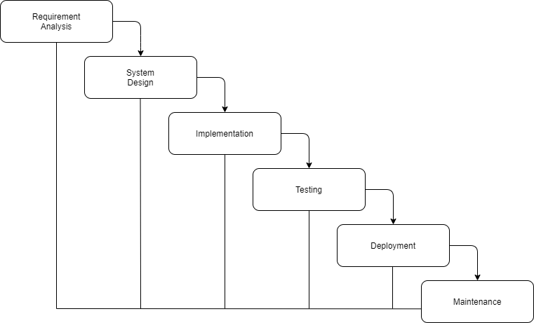

**Figure 2.3: Waterfall Model**

* + - Testing:

The different test cases are performed to test whether the project module are giving expected outcome in assumed time.

All the units developed in the implementation phase are integrated into a system after testing of each unit. Post integration the entire system is tested for any faults and failures.

1. Unit Testing: Checking response when valid username and password is entered and also testing whether a single image is detected or not.
2. Integration Testing: A group of dependent components are tested together to ensure their quality of their integration unit. The face image is uploaded and testing is done whether person is showing depressed when his expressions are angry and sad.
   * + Deployments of System:

Once the functional and non-functional testing is done, the product is deployed in the customer environment or released into the market.

* + - Maintenance:

There are some issues which come up in the client environment. To fix those issues patches are released. Also to enhance the product some better versions are released. Maintenance is done to deliver these changes in the customer environment.

**2.4 Cost and Effort Estimates**

**2.4.1 Cost Estimate**

Cost of project

C=N*Cp

There was no hardware requirement in the project so there was no cost involved for its completion.

Cost = 0 Rs

**2.4.2 Time Estimates Line of Code (LoC):**

Estimating LOC for this project is difficult at estimation stages this project is of innovative type project.

LOC based Estimation:

Efforts in Person in months

*E* = 3*.*2∗(*KLOC*)1*.*05

*E* = 3*.*2∗9*.*01*.*05*to*11*.*0∗4*.*21*.*05

**Table 2.4.2 Estimated LOC**

| Function | Estimated KLOC |
| --- | --- |
| GUI design | 1.1-1.3 |
| Logical code | 1.5-2.0 |
| Location Based code | 1.1-1.3 |
| Directory matching code | 1.0-1.3 |
| Business logic | 2.2-2.5 |
| Testing | 1.1-1.2 |
| Re-correct Code | 1.0-1.2 |
| Total | 9.0-10.11 |

**2.4.3 Man Month Utilization:**

Estimation of the man month is divide into following sub activities:

1-Technical training of the team member: This will take nearly 1 months. This will include Advance java, MySQL, serialization etc.

2-Research: Being an innovative project research for the project is an important part currently it seems to have 1 to 1.5 months

**2.4.4 Project Resources**

• Hardware Resources Required:

* + 1. Processor: Intel i3 and above
    2. Hard Disk: Minimum 100GB
    3. RAM: 4GB

• Software Resources Required:

* + 1. Platform: Windows7 and above.
    2. Backend: python 3.8
    3. Front End: HTML, CSS

**2.5 Project Scheduling**

**Table 2.5: Time line Chart**

| **SR.NO** | **Reporting Date** | **Project Activity** |
| --- | --- | --- |
| 1 | 22 June 2020 | Decide project group member |
| 2 | 29 June 2020 | Submitted 3 Project Topic with IEEE Paper |
| 3 | 13 Jul 2020 | Discuss 5 point analysis of selected IEEE Paper |
| 4 | 20 Jul 2020 | 3 Topics are presented and 1 topic selected |
| 5 | 27 Jul 2020 | Created and Submitted synopsis of a selected project |
| 6 | 03 Aug 2020 | Literature Survey and info gathering of a selected  Project |
| 7 | 10 Aug 2020 | 30 percent project completion and presentation |
| 8 | 31 Aug 2020 | Draw UML diagram of a project |
| 9 | 31 Aug 2020 | 50 percent project completion and presentation |
| 10 | 07 Feb 2021 | 100 percent project completion and presentation |
| 11 | 03 March 2021 | Show the paper published |
| 12 | 23 March 2021 | Show the final report |
| 13 | 6 April 2021 | Show the final PPT |
| 14 | 9 May 2021 | Term 2nd Project overview |

# CHAPTER 3

## ANALYSIS & DESIGN

**3.1 Introduction**

**3.1.1 Methods and Material**

**3.1.1.1. Face Detection**

Face Detection is the first and essential step for processing, and it is used to detect faces in the images. A facial detection system uses biometrics to map facial features from a photograph or video. It compares the information with a database of known **faces** to find a match. **Face detection** systems use computer algorithms to pick out specific, distinctive details about a person's **face**.

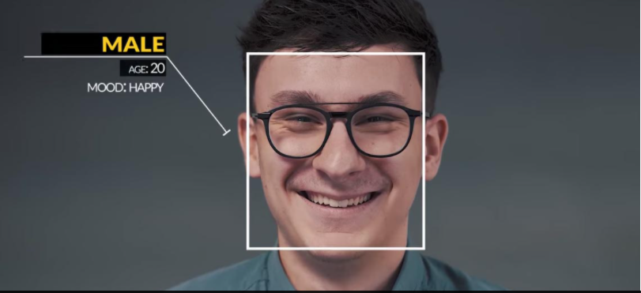

**Fig. 3.1.1.1 face detection**

These details, such as distance between the eyes or shape of the chin, are then converted into a mathematical representation and compared to data on other **faces** collected in a **face** database.

**3.1.1.2. Emotion Detection**

Emotion detection  is used to analyze basic facial expression of human. Emotion recognition system is constructed, including face detection, feature extraction and facial expression classification.

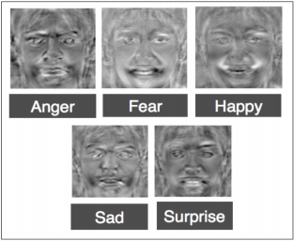

**Fig. 3.1.1.2 Emotion Detection**

**3.1.1.3. Feature Extraction**

Facial feature extraction is the process of extracting face component features like eyes, nose, mouth, etc. from human face image.

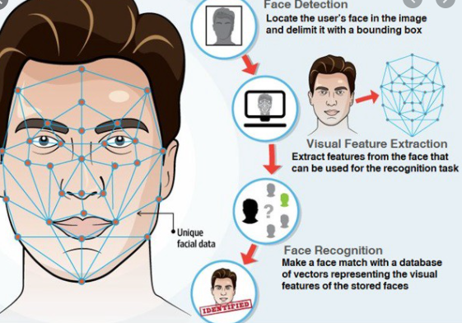

**Fig. 3.1.1.3 Feature Extraction**

 Facial feature extraction is very much important for the initialization of processing techniques like face tracking, facial expression recognition or face recognition.

**3.1.1.4. Emotion Recognition**

The emotions are to be extracted from the detected face. The image that is captured from the camera module, contains the facial features. The detected face is pre-processed (i.e.) cropped and resized. The detectors defined prior can be utilized to identify the emotion and sort them. It must be noted that viola-jones algorithm uses adaboost algorithm with cascading classifier, wherein a series of weak classifier’s classification with a satisfactory threshold is combined to give an acceptable outcome.

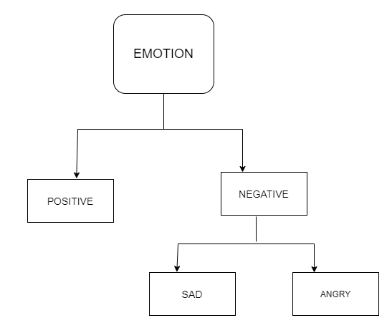

**Fig.3.1.1.4 Emotion Recognition**

**3.1.1.5. Set Stress Threshold:**

After the emotion is detected, it is plotted against the time axis. Over a period of time it is observed and if it crosses an estimated threshold value, some action is performed.

**3.2 Idea Matrix**

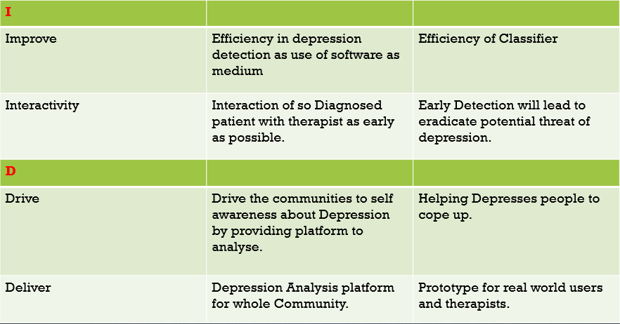

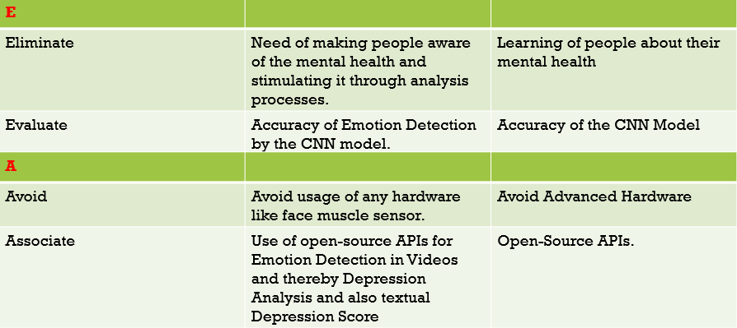

**3.2.1 Methodology**

Face of the subject is captured using the camera module. This detected face is processed and the emotions are classified as either positive or negative emotions. The detected image is processed to identify the face of the subject using Convolutional Neural Network (CNN) algorithm.

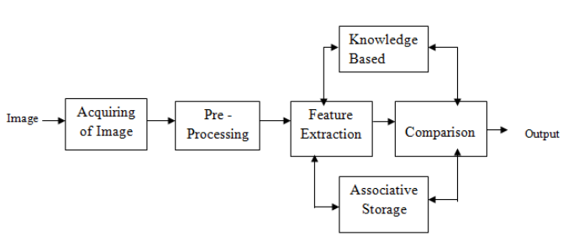

**Fig.3.2.1 Methodology Of the system**

This is plotted and an increase in the negative emotion can be inferred as increase in stress.

**3.3 Mathematical Model**

Receive input data, process the information, and generate output

**Step 1:** Load the input images in a variable (say X)

**Step 2:** Define (randomly initialize) a filter matrix. Images are convolved with the filter

Z1 = X * *f*

**Step 3:** Apply the Relu activation function on the result

A = Relu(Z1)nf

**Step 4:** Define (randomly initialize) weight and bias matrix. Apply linear transformation on the values

Z2 = WT.A + b

**Step 5:** Apply the Relu function on the data. This will be the final output

O = Relu(Z2)

**3.4 Feasibility Analysis (NP Completeness Analysis)**

Problem Statement Feasibility Assessment Using, Satisfiability Analysis and Np Hard, Np-Complete or P Type Using Modern Algebra and Relevant Mathematical Models.

**NP- analysis of system**

**NP Complete**

NP-Complete is the collection of all problems that can be solved in polynomial time using non-deterministic is called NP. That is, a decision question is in NP if there exists an exponent k and a non-deterministic algorithm for the question that for all hints runs in time O (nk) where n is the length of the input. The time taken to feature extraction to obtain new variables from the matrix of the image in order to create distinct classes is performed in polynomial time. So it is NP-Complete. Our project algorithms can be determined in polynomial time but requires indefinite time for db interaction. Hence this project is db file handling project so this project is NP-Complete.

**NP-Hard problem:**

NP-Complete and NP-Hard are: A decision problem is in P if there is a known polynomial-time algorithm to get that answer. The collection of all problems that can be solved in polynomial time is called P. That is, a decision question is in P if there exist an exponent k and an algorithm For the question that runs in time O (nk) where n is the length of the input. A decision problem is in NP if there is a known polynomial-time algorithm for a Non-deterministic machine to get the answer. The estimation cannot be solved in fixed time or we can not define their execution complexity with a mathematical algorithm, are called as Non-Deterministic polynomial problems. A problem is in the class NPC if it is in NP and is as hard as any problem in NP. A problem is NP-hard if all problems in NP are polynomial time reducible to it, even though it may not be in NP itself.

If a polynomial time algorithm exists for any of these problems, all problems in NP would be polynomial time solvable. These problems are called **NP-complete**. The phenomenon of NP-completeness is important for both theoretical and practical reasons.

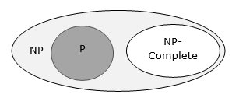

**Fig. 3.4 NP Problem**

**Feasibility Assessment:**

Project algorithm can be determined by polynomial time as it has definite and predictable output. This Process is done within a finite amount of time hence belongs to a NP Complete class Problem.

**3.5 Architecture Diagram**

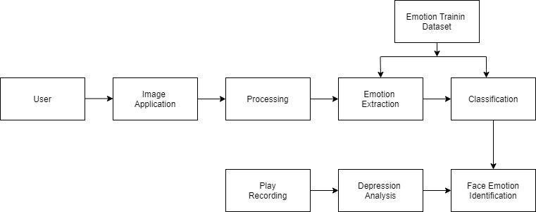

**Fig. 3.5 Architectural Diagram**

**3.5.1 Tools and Technologies Used**

**Python:**

Python is an interpreted, high-level, general-purpose programming language. Its language constructs and object-oriented approach aims to help programmers write clear, logical code for small and large-scale projects.

**CNN:**

A Convolutional neural network (CNN) is a neural network that has one or more convolutional layers and are used mainly for image processing, classification, segmentation and also for other auto correlated data. A convolution is essentially sliding a filter over the input.

**Python Libraries :**

Tensor flow , Numpy , Pandas

**Flask :**

Flask is a python framework used for creating web app.

**3.5.2 Algorithm Details**

**3.5.2.1 Algorithm 1/Pseudo Code**

Image Processing:

In computer science, image processing is the use of computer algorithms to perform image processing on digital images. We used image processing for detecting the faces from camera and to capture emotions on the detected images.

Steps for Image Detection :

Step 1:

Confirm the upper limit of the number of faces to be detected.

Step 2:

Adjust the scaling of the images according to the Device’s Camera.

Step3:

Give access of the device’s camera (to on and off) and pass the camera port as input to OpenCV library’s VideoCapture method.

Step4 : Confirm the frequency of frames needed from the video and capture them within adjusted intervals.

**3.5.2.2 Algorithm 2/Pseudo Code**

Deep Convolutional Neural Network (DCNN):

Input: Test Dataset which contains various test instances TestDBLits [], Train dataset which is build by training phase TrainDBLits[] , Threshold Th.

Output: HashMap ≤class *label, SimilarityWeight* ≥all instances which weight violates the threshold score.

Step 1: For each read each test instances using below equation

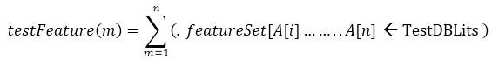

Step 2 : extract each feature as a hot vector or input neuron from testFeature(m) using below equation.



Extracted FeatureSetx[t] contains the feature vector of respective domain.

Step 3: create the number of convolutional

For each read each train instances using below equation.

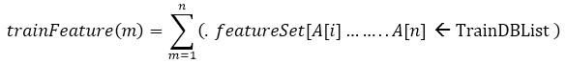

Step 4 : extract each feature as a hot vector or input neuron from testFeature(m) using below equation.



Extracted FeatureSetx[t] contains the feature vector of respective domain.

Step 5 : Now map each test feature set to all respective training feature set GAPS

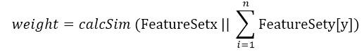

Unable to classify sentiment for heterogeneous images like nature images, animal face images etc.

Traditional CNN is takes more time to train each object and testing respectively. Good accuracy for human face images only not others. Only localize features has consider for sentiment classification is existing research it affect on overall accuracy of error rate.

**3.6 UML Diagrams**

**3.6.1 Data Flow Diagrams**

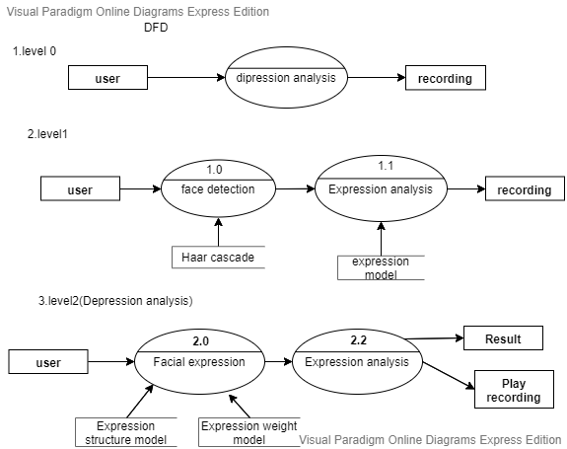

**Figure 3.6.1Data Flow Diagram**

**3.6.2 Use Case Diagram**

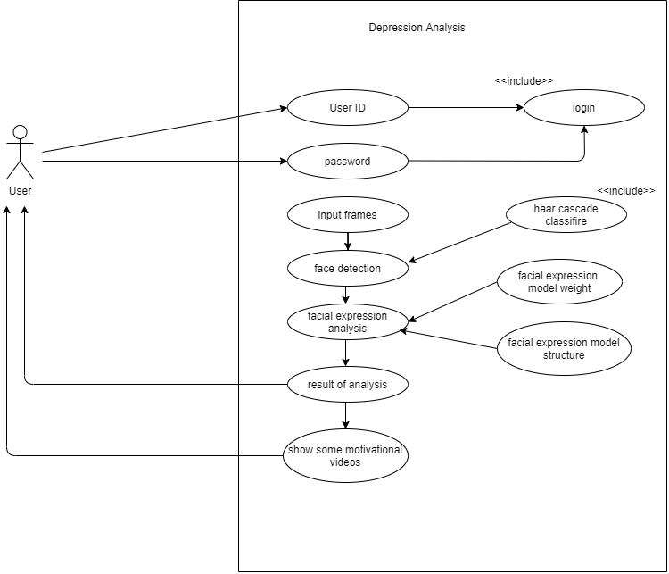

**Figure 3.6.2 Use Case Diagram**

**3.6.3 Sequence Diagram:**

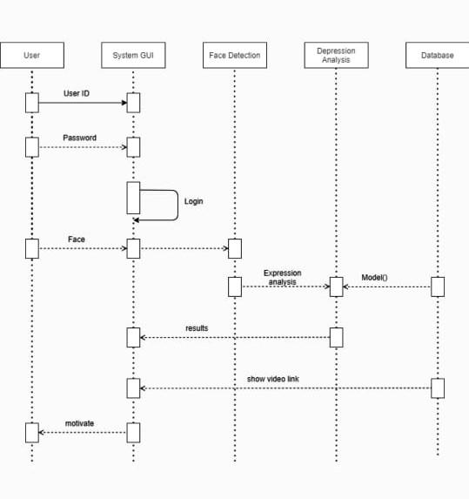

**Figure 3.6.4 Sequence Diagram**

**3.6.4 Class Diagram:**

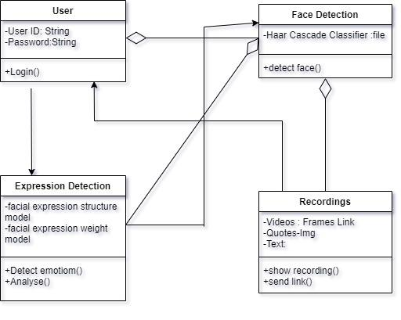

**Figure 3.6.4 Class Diagram**

**3.6.5 Activity Diagram**



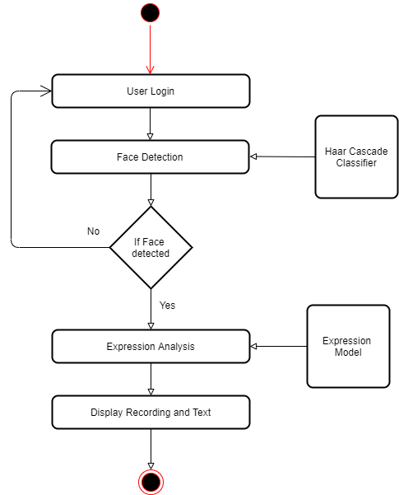

**Figure 3.6.5 Activity Diagram**

**3.6.6 Component Diagram**

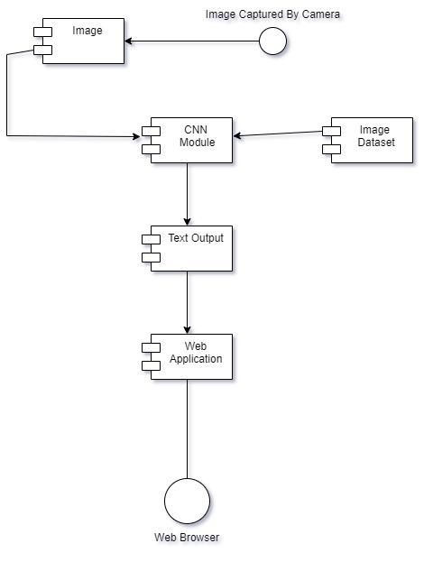

**Fig. 3.6.6 Component diagram**

# CHAPTER 4

## RESULTS & DISCUSSION

**5.1 Main GUI Snapshot**

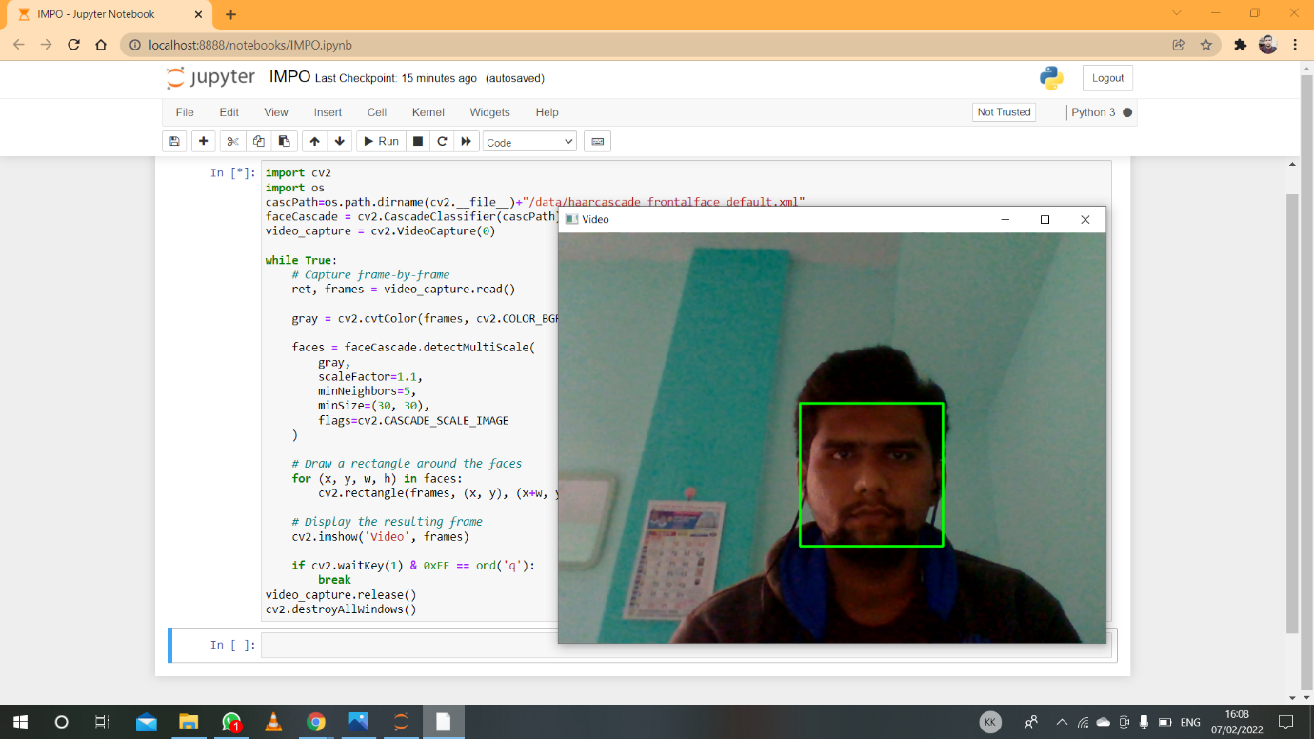

**Fig. 5.1 Face Detection**

**5.2 Discussion**

We are designing a real-time detection system for depression detection. We capture a video using laptop camera and detect a face. In second module using DCNN algorithm and previously recorded dataset find emotions of person and detecting depressed face.

# CHAPTER 5

## CONCLUSION

The proposed system is successful at predicting depression in the test data from the dataset and also from real time video of user. In real world scenario when integrated with various web platforms, this system can create awareness about depression and also provide interface to detect their existing/upcoming depression. This model can help psychologists to detect depression of individuals and can suggest directions for future depression-related studies.

# REFERENCES

1. Author_Name : Aldarwish MM, Ahmad HF.

Topic_Name : Predicting depression levels using social media posts. In: 2017 IEEE 13th

international Symposium on Autonomous decentralized system (ISADS).

Year Of Published : 2017

2. Author_Name : Conway M, O’Connor D.

Topic_Name : Social media, big data, and mental health: current advances and ethical

implications. Curr Opin Psychol.

Year Of Published : 2016

Page no: 77-82

3. Author_Name : Greenberg LS.

Topic_Name : Emotion-focused therapy of depression

Year Of Published : 2017

4. Author_Name : Guntuku SC, et al.

Topic_Name : Detecting depression and mental illness on social media: an integrative

review.

Year Of Published : 2017

5. Author_Name : Mikal J, Hurst S, Conway M.

Topic_Name : Investigating patient attitudes towards the use of social media data to

augment depression diagnosis and treatment In: Proceedings of the fourth workshop on

computational linguistics and clinical psychology from linguistic signal to clinical reality.

Year Of Published : 2017

6. Author_Name : O’Dea B, et al.

Topic_Name : Detecting suicidality on Twitter

Year Of Published : 2015 and 2018

7. Author_Name : Scott J.

Topic_Name : Social Network analysis

Year Of Published : 2017

8. Author_Name : Serrat O.

Topic_Name : Social network analysis In knoledge solutions

Year of Published: 2017

Page no: 39-43

9. Author_Name : Wee J, et al.

Topic_Name : The influence of depression and personality on social networking.

Year Of Published : 2017

10. Author_Name : Zhang L, et al.

Topic_Name : Using linguistic features to estimate suicide probability of Chinese

microblog users. In: International conference on human centered computing.

Year Of Published : 2014

11. Author_Name : Zhou J, et al.

Topic_Name : Measuring emotion bifurcation points for individuals in social media. In

: 2016 49th Hawaii international conference on system sciences (HICSS).

Year Of Published : 2016